**Unit 2 Graded Exercise 4**

The following questions come from the “Check your understanding” examples of each section of Chapter 6 in your textbook.

After you are finished, please submit a Microsoft Word file that contains screenshots of the SQL queries and the output. Remember to put a comment in your queries that contains your name. Your document should be named **U2_GradedExercise4_Lastname.docx**.

(6-7) Question 1:

Use a *create* table statement to create a new copy of the *1_employees* table, with a new name of course. Then use an *insert* statement with a *select* clause to copy all the data from the *1_employees* table to your new copy of the table.

(6-9) Question 2:

Add a primary key to a copy of the employees *table, sec0609_employees*.

(6-11) Question 3:

Add two new columns to a copy of the departments table, *sec0611_departments*. One new column, a text column, will be for the name of the manager of the department. The other new column, a numeric column, is for the annual budget of the department.

(6-12) Question 4:

Expand the length of the *last_name* column of a copy of the employees table, *sec0612_employees*. Expand it to a length of 50 letters so people with hyphenated last names can be hired by the company.

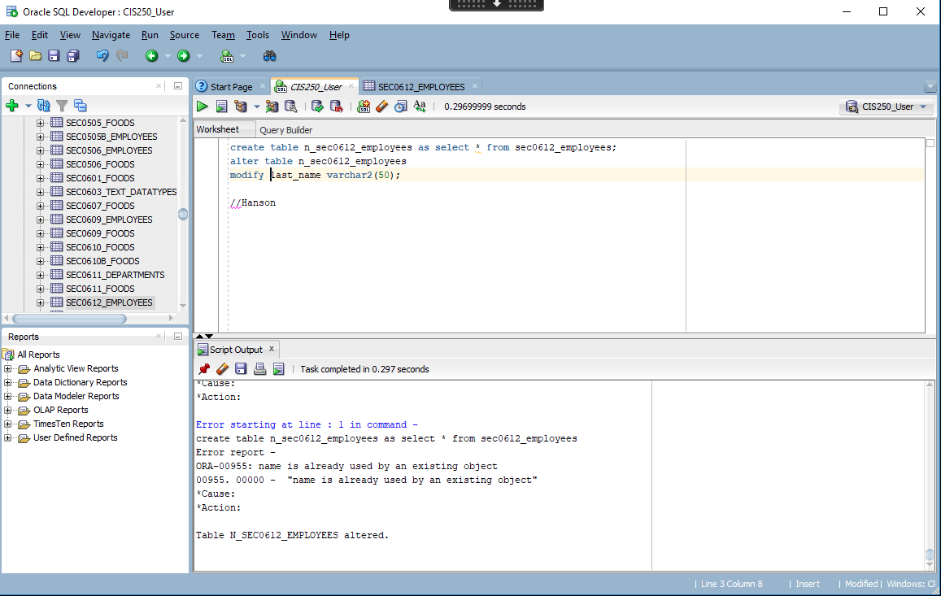

(6-13) Question 5:

Delete the *phone_number* column from a copy of the employees table, *sec0613_employees*.

Made a copy of the table but was not able to delete the column because it said it was a system owned table

(6-16) Question 6:

Eliminate the duplicate rows from the *sec0616_duplicate_rows* table.

(6-17) Question 7:

Assign a number to each row of the *sec0617_duplicate_rows* table.

